Standard Operating Procedure
IACUC/Vivarium

Title of Standard Procedure:
RAPID TAG® Ear Tagging Technique in Mice

Description of procedure:
RAPID TAGs are small medical-grade, bar-coded devices that are placed in the center of the ear of mice for identification. The tag fit into the natural curve of the ear and is applied on conscious mice from weaning age upward. This method is a refinement to conventional metal ear tags allowing for direct automation.

Supplies:
• RAPID applicator
• Ear tags
• Alcohol

General Considerations:
• This method must be approved in the IACUC protocol
• Only trained personnel may perform this technique

Loading the RAPID Applicator (refer to product guide for tips/ Rapidlab.com):

- Holding the applicator in your dominant hand and the tray of tags in your non-dominant hand, position, then gently close, the tips of the applicator onto the edge of the tag (figure 1).
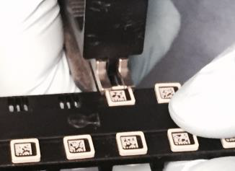

Figure 1

- Maintaining moderate closing pressure, slide the applicator onto the tag until snug. Do not slide the ejector forward. Pushing with your palm, slide the applicator onto the tag until snug (ensure the tag is firmly set in the applicator). DO NOT ROCK THE TRAY OR APPLICATOR SIDE TO SIDE

- Using your thumb, lift the top (with bar-code) half of the tag up and out of the tray.

- Verify alignment with the barcode (male) half. (Female tag should be removed directly out and up, not down and out)

Tag placement:

- Gently restrain the mouse in your non-dominant hand.

- Hold applicator in Tagging position

- With your dominant hand, line the applicator up with inside center of the animal’s ear. Make sure the barcode (male) side is facing you. It’s important that the tag be placed in the correct spot to enable easy scanning and maximum durability.

- With the tag correctly positioned, firmly press the applicator closed until it snaps together to secure the tag (figure 2). NOTE: No pressure or pinching occurs on the ear itself; mice tolerate the tag placement well.

- Once the tag is clicked into place, carefully eject the tag from the applicator by sliding the thumb piece on the applicator forward while disengaging the applicator from the ear.

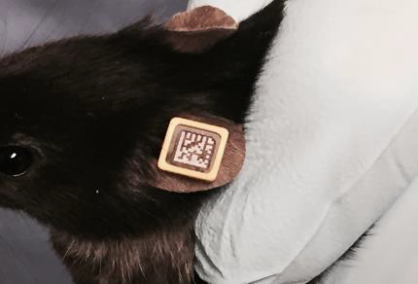

Figure 2

